Dimitra Zirou
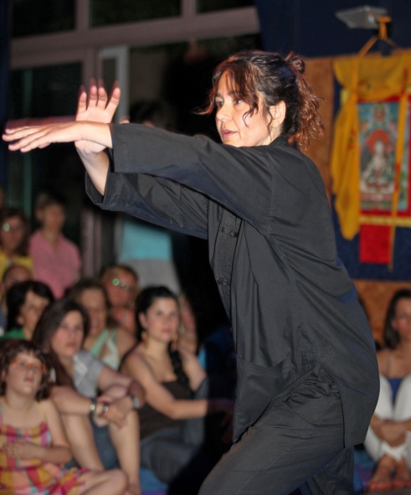

Profile

I began to practice T’ai Chi Ch’uan (Yang school) and Chi Kung in 1992, with Tew Bunnag, founder of the European School of T’ai Chi Ch’uan (http://metta-taichi.org.uk).
Whilst there, I had the opportunity to also practice T’ai Chi and Chinese calligraphy with master Chen as well as Chinese, Thai and Japanese shiatsu massage.

My interest in ideograms since adolescence led me to study the Japanese language for five years and Japanese calligraphy with Toyoko Tada for four years.

I consider meditation as the base of my practice and my teacher and mentor has been Dhiravamsa (http://www.dhiravamsa.com).

In 2002, I began to train in Aikido and Iaido at Shudokan in Athens – Greece with Yannis Tsorotiotis Sensei 5th Dan, who sadly died at the end of 2014 and since then Shudokan has been working with Aikido for Daily Life. As a result, I was graded and received my Shodan in June of 2016 from Piers Cooke Sensei, 7th dan.

I have been teaching T’ai Chi Ch’uan, Chi Kung and meditation since 2001.
I am presently teaching at Shantom (www.shantala.gr) - since 2004,
and have taught at Aikido Academy (www.aikidoacademy.gr) ( 2014 - 2016) in Athens.

As T’ai Chi Ch’uan is one of the oldest martial arts, belonging to the “internal” martial arts of China, so Aikido is considered to be the quintessence of all Japanese martial arts.
In both T’ai Chi and Aikido practice I have been looking for the possible ways to transform inherited human energy patterns of violence into understanding, compassion and self growth. It is a lifetime process, and I dedicate the energy of my practice to this purpose.

Session

THE FIVE ELEMENTS AND THE SIX HEALING SOUNDS
From Japanese Kototama to ancient Chinese movement-sound forms.

The development of the cycle of the Five Elements as a way of understanding and describing the phases of change in nature and within the human body dates back to the Taoist Tsou Yen (305 – 240 b.c) and forms the basic ground for both T’ai Chi and Chinese Medicine.
The Six Healing Sounds in China have their origins in the disciplines of physical and spiritual training that are rooted in the experience of the human organism as a constantly

transforming dynamic of interactive energies that are seen in terms of the Five Elements.
The expression of these sounds, accompanied by the right directional flow of energy and their equivalent movements, is a way of vibrating the organism and promoting the circulation of blood and enhancing the quality of Ch’i / Ki.

The closest equivalent in the Japanese tradition are the Kototama “Word Spirit” sacred sounds, re-introduced to modern Japan and practiced on a daily basis by O Sensei.

In this session we will go through the basic understanding and martial substance of each one of the Five Elements and link them to their corresponding Six Healing Sound-movement forms.

