Thomas Christaller

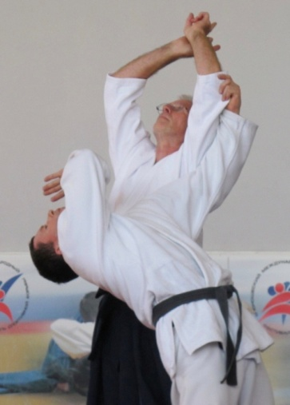

Thomas Christaller (born 6. May 1949 in Bonn) is a Professor emeritus of Artificial Intelligence. Since then he has concentrated on teaching aikido. To this end he cofounded the enterprise "Bewegung & Lebenskunst" (engl. Moving & Art to Live) where body-based systems are taught, which includes different martial arts, plus practices such as yoga and Feldenkrais, which all aim to strengthen the autonomy of an individual including his or her health. For over 13 years he has been a member of the partnership network, ‘Quest-Team’, giving talks on what brain sciences tell us about our behaviours in leadership positions as well as in general contexts at work in enterprises and organizations. He collaborated with neuro- and behaviour-biologists to build autonomous mobile robots, learning a lot about the relationships between body and mind.
His aikido career started in Bonn 1972 where he joined the local aikido club which was founded in 1966. His main direct teachers were Klaus Broscheit and Norbert van Soest. He graduated up to 4th Dan under Katsuaki Asai Shihan in 2003. During his first visit to Japan in 1986 he attended a class of Nobuyuki Watanabe Shihan at Hombu Dojo, Tokyo. He was fascinated by the ease and effortless movements of Watanabe Shihan. In 2019 he was promoted to 6th Dan by suggestion of Watanabe Shihan. He started to teach Aikido in 1977 at the University of Bielefeld and continues to do so today. Since 2008 he has taught full-time at the Center for ‘Moving & Art to Live’ in Bonn. For some years now he has been invited to give seminars in Germany and abroad, e.g. Moscow (see the video links at Vimeo below), Cambridge, and the USA. In his aikido he concentrates on the very first moment of contact to develop an attitude which he calls Gentle Touch.

WEB RESOURCES FOR MORE INFORMATION
http://de.wikipedia.org/wiki/Thomas_Christaller
http://www.iais.fraunhofer.de/index.php?id=19&L=1
http://www.lebenskunst-bonn.de/
https://vimeo.com/channels/bul

Sessions

Why is it important to learn how to attack

Aikido is perceived as a peaceful martial art. The aim is for tori, (the person receiving the attack), to join the forces, physically and mentally, with uke, (the person who gives the attack). Tori needs an attack in order to be able to learn technique. However, it is not uncommon to see that the attack offered lacks intent. All to often the attack seems to stop at the point of contact. This doesn’t happen in other martial arts, e.g. karate where the attacker will try to launch a second or third attack, if the opportunity presents itself.

There are sixteen different categories of attack in the aikido curriculum. But they aren’t part of an examination or test and they are very rarely taught explicitly. Even in the literature, I know of only two books that seek to explain the attacks. (e.g.Stefan Stenudd’s book ‘Attacks in Aikido) solely. And the question is, if aikido is a peaceful martial art, why should we care about the attack?

One obvious answer is that without a decent attack we maybe can’t learn good aikido technique. If the attack lacks reality, then we simply don’t know if we can reproduce it, just when we need it most. Like as not, we won’t be able to. But there is, I suggest, a deeper reason why we should care about learning how to attack properly. Firstly, if the intent from uke stops at the point of contact, then there is nothing for tori to blend with. Secondly without the intent of uke to cause harm, how can the tori learn how to transform this negative energy into something positive. Only then can we develop an understanding how to be peaceful and empathetic even in the most challenging situations.

In this session we explore some of the classical attacks in aikido, learning how to do them not as a trigger or basis for performing great aikido movements, but make them meaningful in themselves. We will explore why these attacks are attacks which deliver control, pain, and more.

Then we will look at how tori can take this negative intent and not only ensure that they are safe, but are able to ensure uke’s well-being too.

Finally we will explore how a good attack can help us to learn aikido techniques much more efficiently. We will discover that the role of uke is much more complex and demanding then we may have thought. It will become clear that attacks are a teaching tool for learning aikido and that it doesn’t matter what role you are performing on the mat, tori or uke, the learning never stops.

Aikido and Depression. A personal tour.

Winston Churchill, the man who made the V for victory sign his personal flagship, who literally put on a brave face , when the UK was on its knees, was in fact a person who suffered from depression. He called it his black dog. It is common, yet it is not really talked about and in the world of aikido, where everything is supposed to be positive, it is simply ignored. But aikidoka are humans like everyone else and in fact many people come to aikido as a way of finding a solution to problems like depression

Based upon my own experiences of having my own black dog I want to explore aspects in aikido, which may support you in dealing with this issue either personally or with students.

