Marill Poole

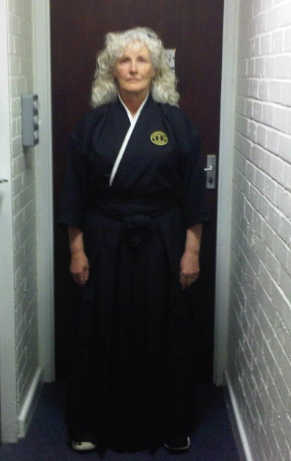

Profile

7th Dan

I started Aikido in 1980 under the direction of Sensei Jack Poole 7th Dan, and founder of the UK Shinwakai Organisation. I hold Dan grades in both Yoshinkan and Aikikai styles of Aikido, and the main reason for studying these two styles was to incorporate the structure and discipline of Yoshinkan, with the flowing movements of Traditional Aikido, and to promote a true family spirit through Aikido. Over the years we have met other like-minded organisations and regularly train together in harmony and sharing of knowledge.
I worked for the NHS as a Manual Handling Adviser and promote Aikido on a daily basis teaching staff to power through their legs rather than using upper body strength. I have found that the language of Aikido is universal and transcends all spoken language and that it doesn’t matter what service I taught in my professional world the common dominator is the principal of Aikido. When dealing with patients I very often say to staff ‘’ what are your hands saying to your patients’’. I am a great believer that contact and of course the correct contact is paramount to a patient and speaks a thousand words much more so than verbal communication, and this is also true in Aikido when connecting with your partner. Movement patterns are universal.
Session

First Contact

The theme will be about the moment of first contact with Uke and knowing the first moment of imbalance. Now the conversation can begin.

